|  |  |  |  |  |
| --- | --- | --- | --- | --- |
| Ozark Maltese Cross Flat | **Ozark Fire Protection District** | | | |
| Jarett Metheny | | | |
| *Fire Chief* | | | |
|  | | | |
| 604 N. 3rd Street |  | PHONE: | (417) 581-4436 |
| P.O. Box 917 |  | FAX: | (417) 581-4496 |
| Ozark, MO 65721 |  | WEB: | www.ozarkfire.org |
|  | | | | |

Posted: Thursday, May 15, 2025, at 5:00 p.m.

Notice is hereby given that the Ozark Fire Protection District will conduct a meeting on

**Tuesday, May 20, 2025, at 6:00 pm at**

**Ozark Fire Protection District, 604 N. 3rd Street, Ozark, MO**

**The tentative agenda of this meeting includes:**

1. Pledge of Allegiance and Ceremonial Matters.
2. Call to Order.
   1. Roll Call.
   2. Approval of Agenda.
   3. Acceptance of the April 15, 2025, Regular Board Meeting Minutes.
   4. Previously Registered Guest.
3. Financial Report.
4. Staff Report.
5. Old Business.
   1. Discussion and Consideration of Capital Projects.
   2. Discussion and Consideration of Ozark Marketplace Development Tax Abatement Ordinance.
6. New Business.
   1. Discussion and Consideration of the Equipment Purchases through the Firehouse Subs Grant.
   2. Discussion and Consideration of Managed IT Services RFP.
7. Adjournment of Regular Meeting.
8. Closed Session.
   1. RSMo 610.021(3) – Personnel Matter
   2. RSMo 610.021(13) – Personnel Evaluation
   3. RSMo 610.021(9) – Collective Bargaining Agreement Negotiations
9. Open Session.
10. Adjournment.

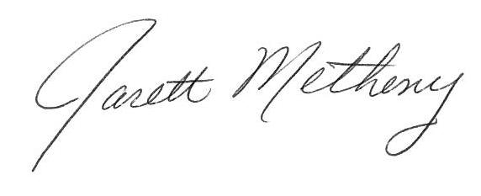

Submitted By: ______________________________ Date: May 15, 2025

Jarett Metheny, Fire Chief

The news media may obtain copies of this notice by contacting:

Ozark Fire Protection District Office

604 N. 3rd Street, Ozark, MO 65721