|  |  |  |  |  |
| --- | --- | --- | --- | --- |
| Ozark Maltese Cross Flat | **Ozark Fire Protection District** | | | |
| Jarett Metheny | | | |
| *Fire Chief* | | | |
|  | | | |
| 604 N. 3rd Street |  | PHONE: | (417) 581-4436 |
| P.O. Box 917 |  | FAX: | (417) 581-4496 |
| Ozark, MO 65721 |  | WEB: | www.ozarkfire.org |
|  | | | | |

Posted: Tuesday, June 10, 2025, at 12:00 p.m.

Notice is hereby given that the Ozark Fire Protection District will conduct a meeting on

**Tuesday, June 17, 2025, at 6:00 pm at**

**Ozark Fire Protection District, 604 N. 3rd Street, Ozark, MO**

**The tentative agenda of this meeting includes:**

1. Pledge of Allegiance and Ceremonial Matters.
2. Call to Order.
   1. Roll Call.
   2. Approval of Agenda.
   3. Acceptance of the May 20, 2025, Regular Board Meeting Minutes.
   4. Previously Registered Guest.
3. Financial Report.
4. Staff Report.
5. Old Business.
   1. Discussion and Consideration of Ozark Marketplace Development Tax Abatement Ordinance.
6. New Business.
   1. Discussion and Consideration of Architectural Services Contract Amendment.
7. Adjournment of Regular Meeting.

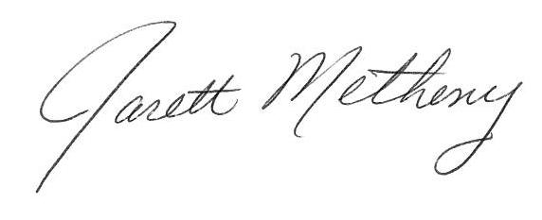

Submitted By: ______________________________ Date: June 10, 2025

Jarett Metheny, Fire Chief

The news media may obtain copies of this notice by contacting:

Ozark Fire Protection District Office

604 N. 3rd Street, Ozark, MO 65721